BookControllerTests
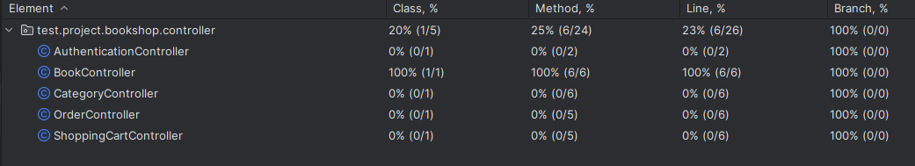
CategoryControllerTests
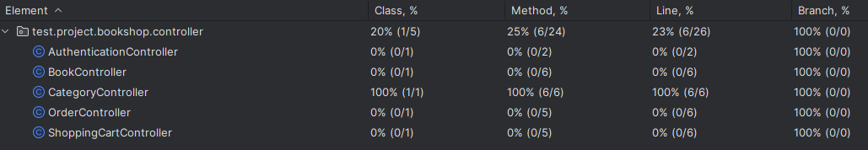
BookServiceImplTests
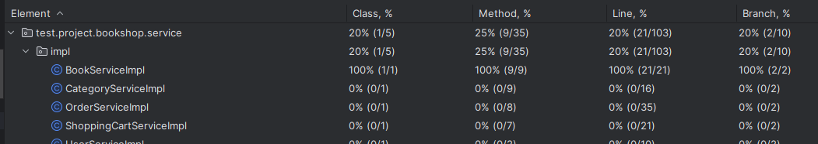
CategoryServiceImplTests
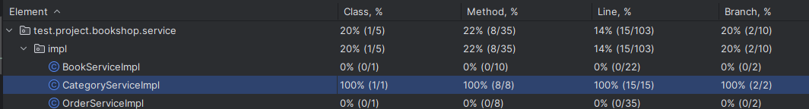
BookRepositoryTests
